**Asynchronous Data Transfer**

**Two units in a computer, CPU and I/O interface are designed independently of each other. If the registers in the interface share a common clock with CPU registers, the transfer between two units is said to be synchronous.**



**When speed of I/O devices does not match with CPU, timing in each unit is independent from other and each uses its own private clock for internal registers. In that case, the two units are said to be asynchronous to each other.**

**In this method, process initiates the device and checks its status. As a result, CPU has to wait till I/O device is ready to transfer data. When device is ready, CPU issues instruction for I/O transfer.**

**There are two ways to achieve asynchronous data transfer method**



**1. Strobe Control**

**2 Handshaking**

**Strobe Control**

**The strobe control method of Asynchronous data transfer employs a single control line to each transfer. The strobe may be activated by either the source or the destination unit.**

**Data Transfer Initiated by Source Unit:**

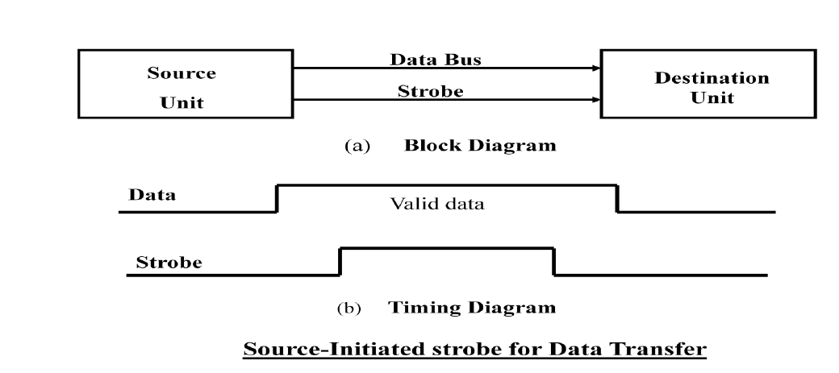

**In the block diagram fig(a), the data bus carries the binary information from source to destination unit. Typically, the bus has multiple lines to transfer an entire byte or word. The strobe is a single line that informs the destination unit when a valid data word is available.**

**As shown in the timing diagram fig (b) the source unit first places the data on the data bus. The information on the data bus and strobe signal remains in the active state to allow the destination unit to receive the data.**

**Data Transfer Initiated by Destination Unit:**

**In this method, the destination unit activates the strobe pulse, to informing the source to provide the data. The source will respond by placing the requested binary information on the data bus.**

**The data must be valid and remain in the bus long enough for the destination unit to accept it. When accepted the destination unit then disables the strobe and the source unit removes the data from the bus.**

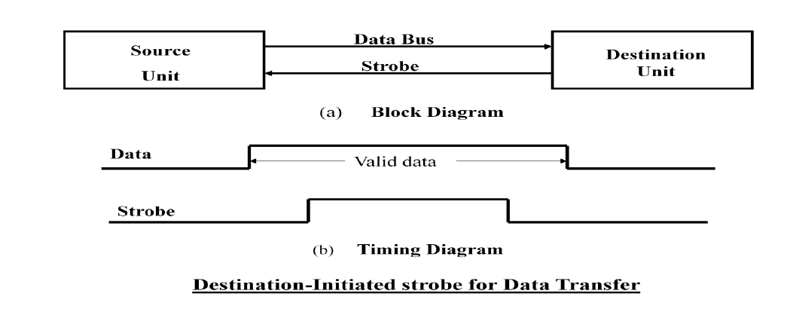

**Disadvantage of Strobe Signal:**

**The disadvantage of the strobe method is that, the source unit initiates the transfer has no way**

**of knowing whether the destination unit has actually received the data item that was placed in**

**the bus. Similarly, a destination unit that initiates the transfer has no way of knowing whether**

**the source unit has actually placed the data on bus. The Handshaking method solves this problem.**

**Handshaking**

**The handshaking method solves the problem of strobe method by introducing a second control signal that provides a reply to the unit that initiates the transfer.**

**Principle of Handshaking:**

**The basic principle of the two-wire handshaking method of data transfer is as follows:**

**One control line is in the same direction as the data flows in the bus from the source to destination. It is used by source unit to inform the destination unit whether there a valid data in the bus. The other control line is in the other direction from the destination to the source. It is used by the destination unit to inform the source whether it can accept the data. The sequence of control during the transfer depends on the unit that initiates the transfer.**

**Source Initiated Transfer using Handshaking:**

**The sequence of events shows four possible states that the system can be at any given time. The source unit initiates the transfer by placing the data on the bus and enabling its data valid signal. The data accepted signal is activated by the destination unit after it accepts the data from the bus. The source unit then disables its data accepted signal and the system goes into its initial state.**

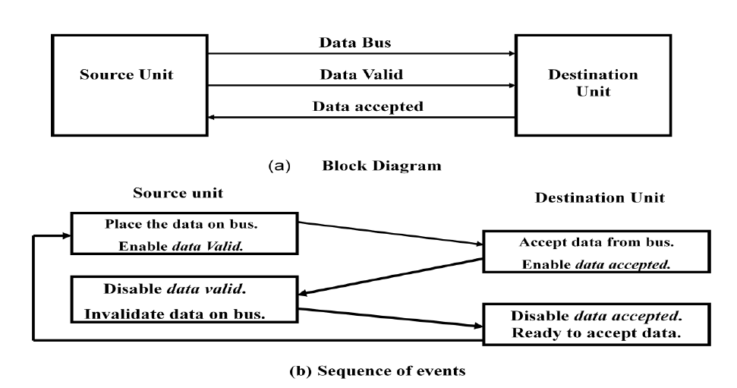

**Destination Initiated Transfer Using Handshaking:**

**The name of the signal generated by the destination unit has been changed to ready for data to reflect its new meaning. The source unit in this case does not place data on the bus until after it receives the ready for data signal from the destination unit. From there on, the handshaking procedure follows the same pattern as in the source initiated case.**

**The only difference between the Source Initiated and the Destination Initiated transfer is in their choice of Initial state.**

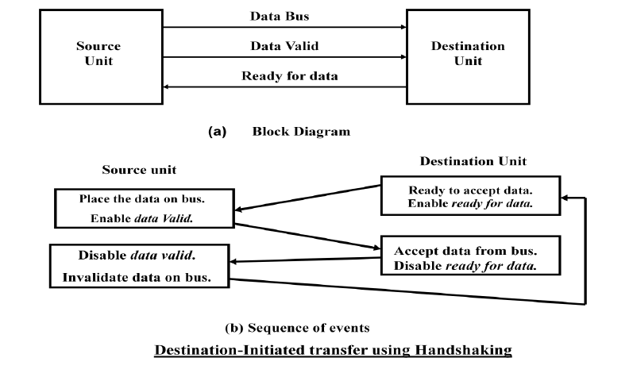

**Advantages of the Handshaking method:**

**The Handshaking scheme provides degree of flexibility and reliability because the successful completion of data transfer relies on active participation by both units.**

**If any of one unit is faulty, the data transfer will not be completed. Such an error can be detected by means of a *Timeout* mechanism, which provides an alarm if the data transfer is not completed within a predetermined time.**

**The time out is implemented by means of an internal clock that starts counting time when the unit enables one of its handshaking control signals. If the return handshake signal does not respond within a given time period, the unit assumes that an error has occurred.**